**SORTING ALGORITHMS SET 1**

**RIZWANA RASHEED**

**AM.SC.P2CSC19026**

**a)BUBBLE SORT**

#bubblesort

def bubbleSort(arr):

n = len(arr)

for i in range(n):

for j in range(0, n-i-1):

if arr[j] > arr[j+1] :

arr[j], arr[j+1] = arr[j+1], arr[j]

list=[]

size=int(input("Enter the size"))

for i in range(size):

elements=int(input())

list.append(elements)

print(list)

bubbleSort(list)

print ("Sorted array is:")

print(list)

**OUTPUT:**

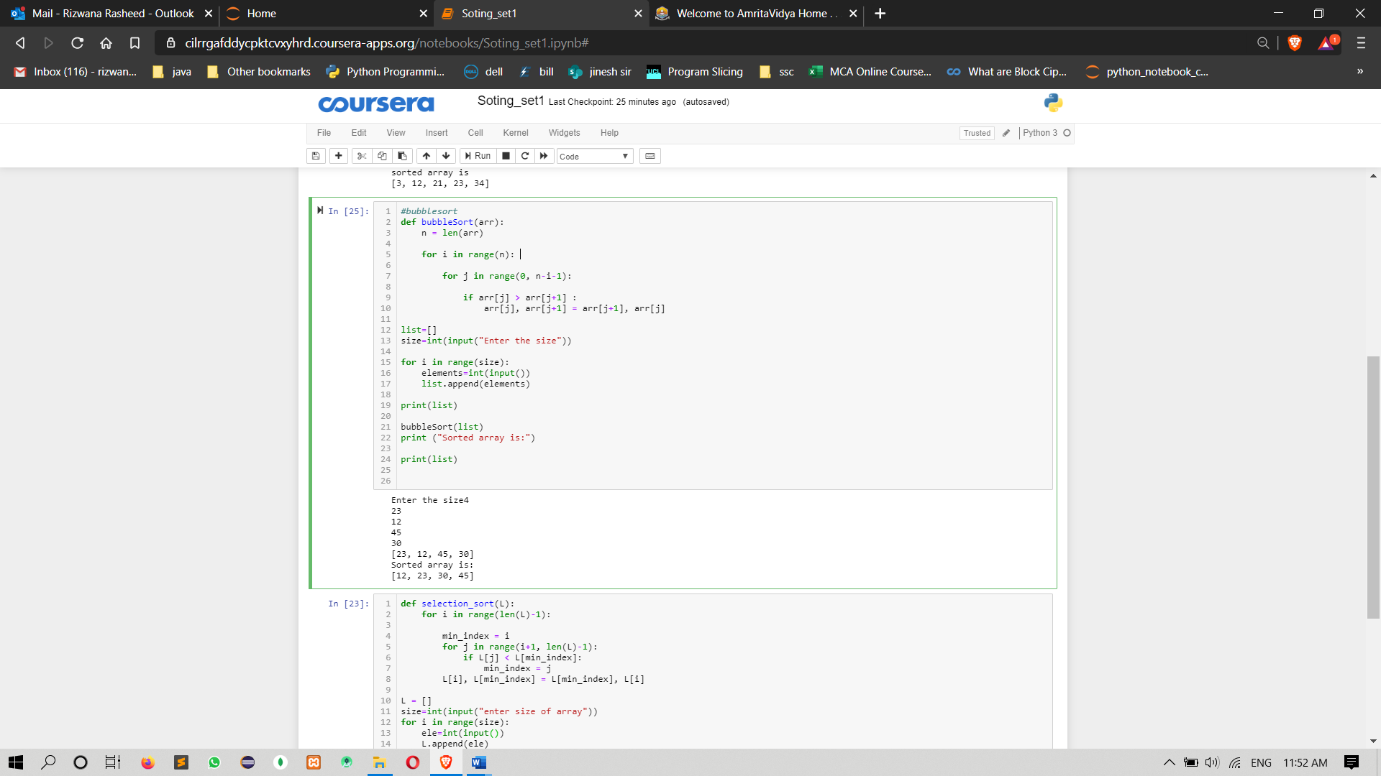

**b)SELECTION SORT**

def selection_sort(L):

for i in range(len(L)-1):

min_index = i

for j in range(i+1, len(L)-1):

if L[j] < L[min_index]:

min_index = j

L[i], L[min_index] = L[min_index], L[i]

L = []

size=int(input("enter size of array"))

for i in range(size):

ele=int(input())

L.append(ele)

print(L)

selection_sort(L)

print("sorted array is:")

print(L)

**OUTPUT:**

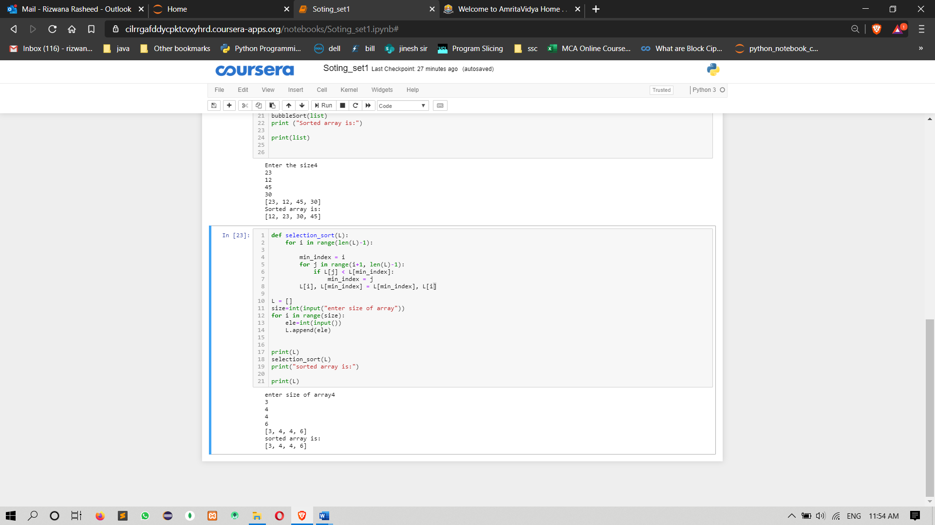

**c)INSERTION SORT**

#insertion sort

def insertionSort(arr):

for i in range(1, len(arr)):

key = arr[i]

j = i-1

while j >= 0 and key < arr[j] :

arr[j + 1] = arr[j]

j -= 1

arr[j + 1] = key

list=[]

size=int(input("Enter the size"))

for i in range(size):

elements=int(input())

list.append(elements)

print(list)

insertionSort(list)

print("sorted array is")

print(list)

**OUTPUT:**

